How to send email address using cidbec.com.my
- Login to your email and click on gear icon and click on setting
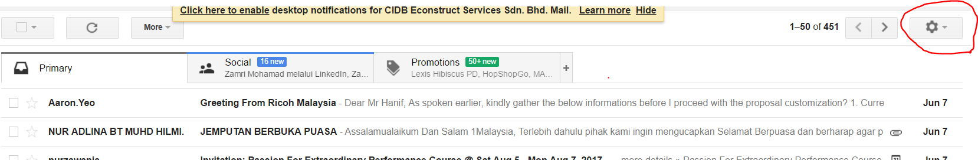

- Click on Accounts tab and go to Add Another Email Address in “Send Email as” section.
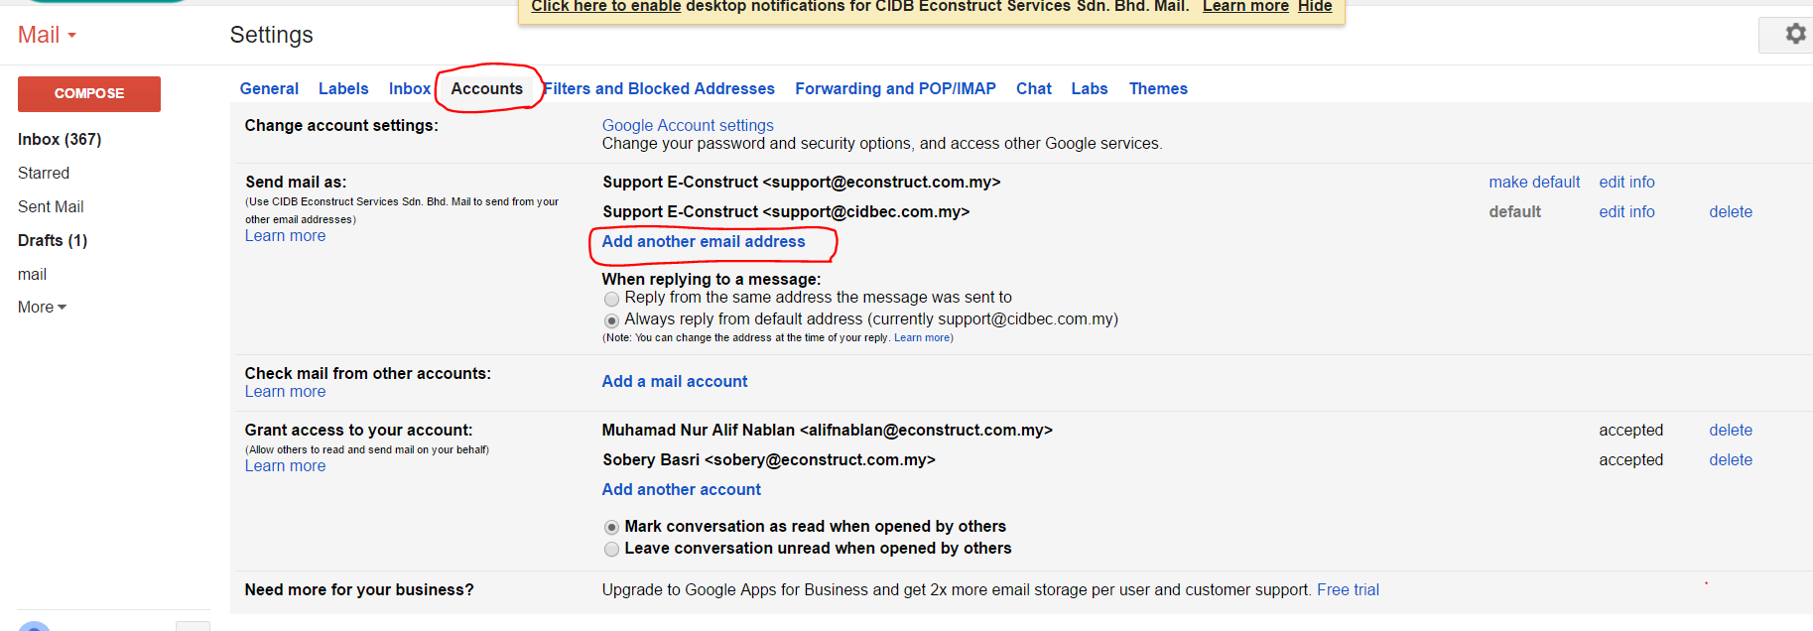

- Insert your new email address. ie: support@econstruct.com.my -> support@cidbec.com.my and click next.

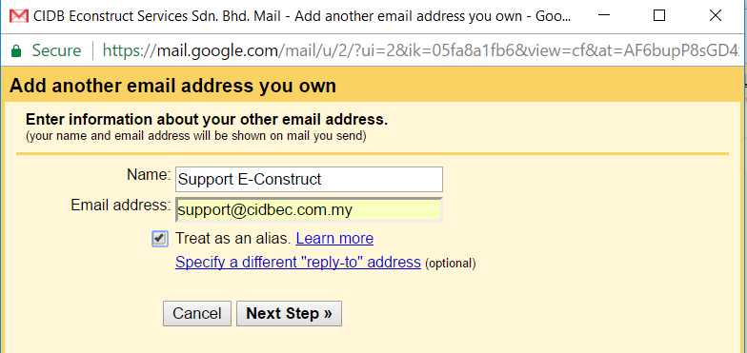

- Click “make default” to make this email as a default email address.
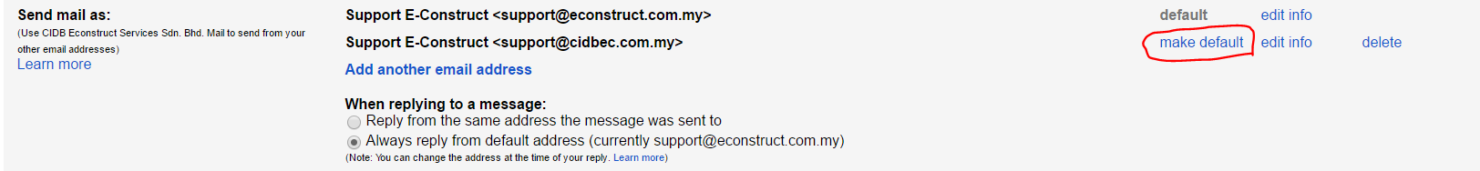

- Finally, we can already send email using new email address.
