How to send email address using cidbec.com.my

1. Login to your email and click on gear icon and click on setting

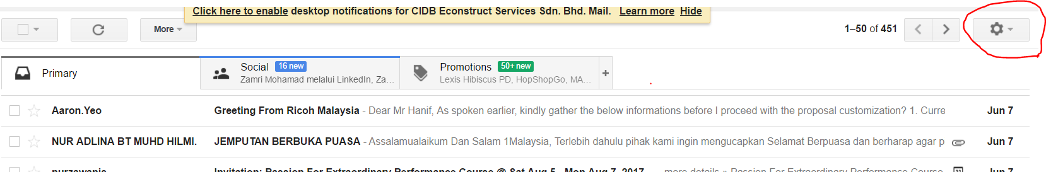

1. Click on Accounts tab and go to Add Another Email Address in “Send Email as” section.

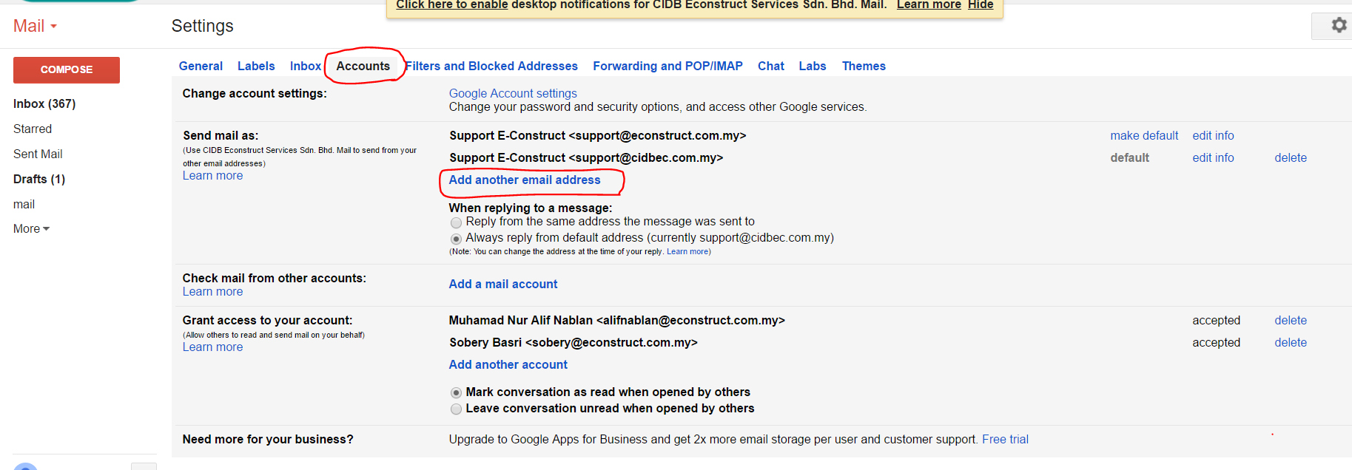

1. Insert your new email address. ie: [support@econstruct.com.my](mailto:support@econstruct.com.my) -> [support@cidbec.com.my](mailto:support@cidbec.com.my) and click next.

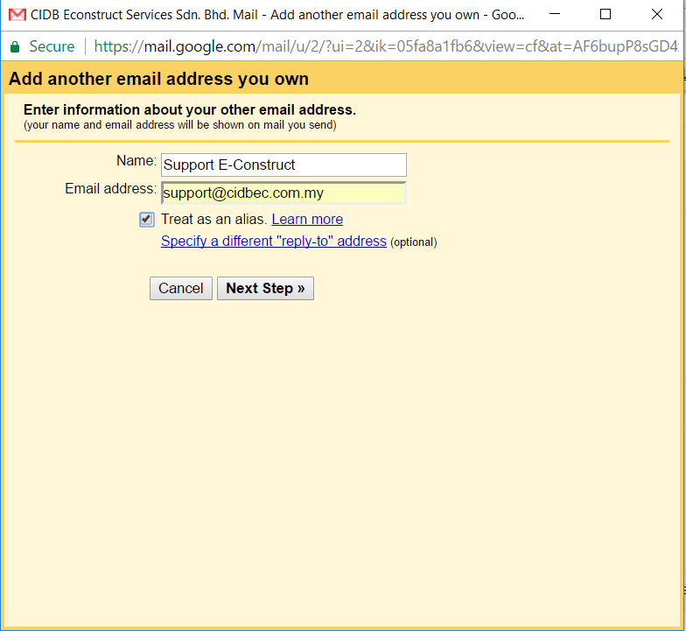

1. Click “make default” to make this email as a default email address.

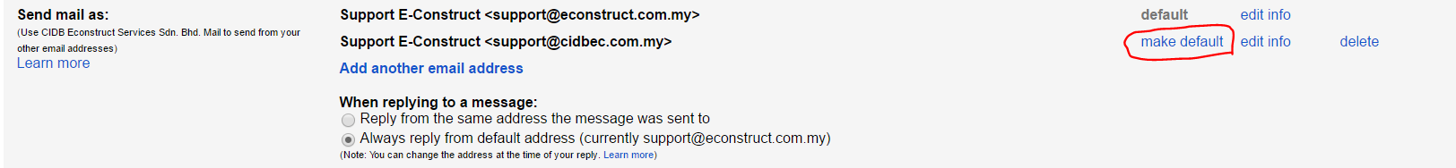

1. Finally, we can already send email using new email address.

